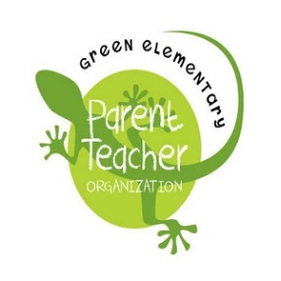
Green Elementary PTO Agenda
Tuesday, October 3rd 2017, 7pm
Multi Purpose Room, Green Elementary School

- Call to Order (Erin)
  - Introductions (everyone) (5 MIN)
  - Meeting protocol- “friendly version” (Erin and James) (3 MIN)
- * Review & Approval of Agenda (Erin) (2 MIN)
- * Review & Approval of September 12, 2017 Minutes (Erin) (3 MIN)
- *Treasurers Report (Jessica and Kerri) (5 MIN)
- New Business
  - Adoption of comprehensive Contract for programs* (Erin presents and yields to Heidi and James) (5 MIN)
  - Rescinding of Aragon music from the budget* (Erin) (2 MIN)
  - Presentation, Discussion and Board Vote on Programs * (Principal McClure) (35 min)
    - Fletcher Hills Tennis
    - Residency Performing Arts Program- Rechelle Conde Nau
    - Take the Stage- Ryan Tafolla
    - Art Reach
    - Art Corp Program
    - Chris Rubio Productions- 2 assemblies
    - La Jolla Playhouse program
- Reports
  - Programs sub-committee- (Elizabeth Grell) (5 MIN)
  - Fundraiser Chair- (Heidi Runge) (10 MIN)
    - Taste of Navajo (Erin Liddell)
    - Pledge Drive (Elizabeth Grell + Heidi Runge)
    - Bricks (Catherine Gagnon)
    - Golf Tickets
    - Gecko Gear (Paula Serno)
    - Amazon Smile/ Boxtops- (Kelly Koury)
    - Gala- (Azizi James + co-chair)
    - Jog a thon (Tracy Karson + Heidi Runge)
  - Infrastructure- (Maria Yabut-Koury) (5 MIN)
    - Grant possibilities
    - Projects around Green
    - Gecko Dad Corp Projects/ Events- (Cory Hazelwood, Mark Naiman)
  - Activities and Events- (Kelley Stein Murphy) (5 MIN)
    - Gecko Grind- (Sandy Mcann)
    - Family Read
    - Possible enrichment nights for parents and children
  - Membership- (Elizabeth Grell) (5 MIN)
    - “opt in” for membership forms
    - Mailchimp
  - Marketing- (Monique McNeal) (5 MIN)
    - Website (Kelley)
    - Facebook
    - Room Parent Boot Camp- (Sandy McCann)
    - Signage/ alerts for up and coming events
    - “Ways to recognize Green” (YELP, facebook, website)
- Good and Welfare (Erin) (2MIN)
- Adjournment (Erin) (1 MIN)
*Requires a vote by the board

